



**Web Scraping Bewakoof Men's Bestsellers ( )**

**Project By – Mr. Harshal Shirsekar**

**Guided By - Mr. Sameer Warsolkar**



**Web Scraping Bewakoof Men's Bestsellers**

1. **Aim:**

To extract key product information including the product title, size, models/variants, price, ratings, and special offers.This data will facilitate market analysis, product comparison, and consumer trend insights.

1. **OBJECTIVE:**

**●Data Collection:**

Gather detailed information on eyeglasses, including product titles, sizes, models/variants, prices, ratings, and special offers.

**●Database Creation:**

Compile the scraped data into a structured format to create a comprehensive database for easy access and analysis.

**●Price Monitoring and Analysis:**

Track and analyze price trends over time to identify the best times to buy and to monitor pricing strategies.

**●Customer Feedback Analysis:**

Gather and analyse customer ratings and reviews to assess product quality and customer satisfaction.

**●Structured Data Frame Generation:**

Convert the extracted data into a well-organized dataframe format for efficient analysis.

1. **OUTLINE:**

From this site, we are going to grab the following information:

* BRAND NAME
* DESCRIPTION
* PRICE(Rs)
* MEMBERSHIP PRICE(Rs)
* TYPE OF FABRICS

1. **Steps:**

**●** **Choose the Website and Webpage URL:**

The first step is to select the website you want to scrape. We will extract data of Eyeglasses from **bewakoof.com**

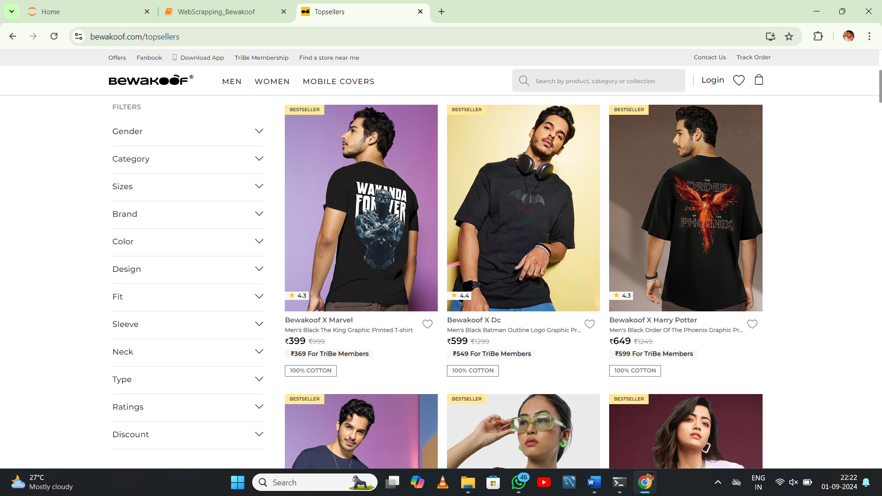

### Inspect the website:

### Now the next step is to understand the website structure. Understand what the attributes of the elements that are of your interest are. Right click on the website to select “Inspect”. This will open HTML code. Use the inspector tool to see the name of all the elements to use in the code.

### 

### Installing the important libraries:

### Python has several web scraping libraries. We will use the following libraries:

### Requests – for making HTTP requests to website

### BeautifulSoup – for parsing the HTML code

### Pandas – for storing the scraped data in data frame

### Write the Python source code:

### We’ll write the main python code. The code will perform the following steps:

### Using requests to send an HTTP GET requests

### Using BeautifulSoup to parse the HTML code

### Extracting the required data from the HTML code

### Store the information in a pandas DataFrame

### Exporting the extracted data:

### We’ll export the data as a CSV file.

### We’ll use the pandas library.

### Benefits:

### Access to Valuable Data

### Automation of Data Collection

### Real-Time Insights

### Risks:

### Legal Issues

### IP Blocking and Rate Limiting

### Data Accuracy and Integrity

1. **Lenskart Eyeglasses Web Scraping Coding Commands:**
2. **Accessing Men’s T-Shirts on the Bewakoof website using the requests and BeautifulSoup libraries:**

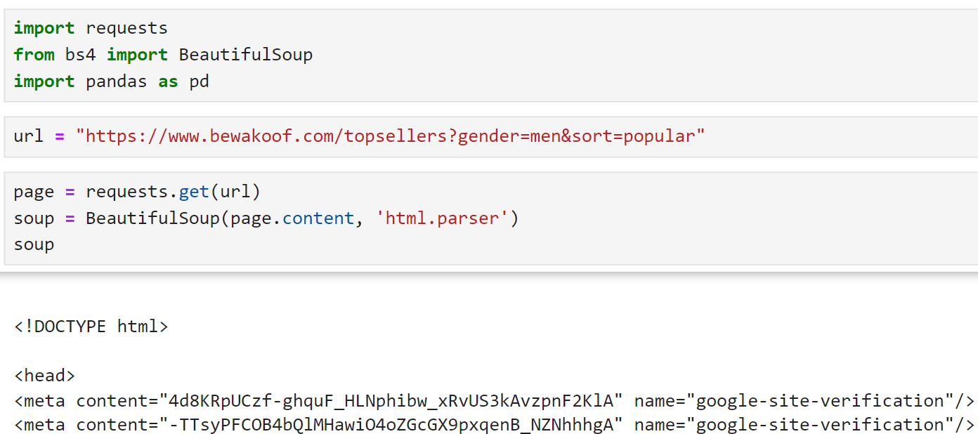

1. **Accessing the Brand_Names:**

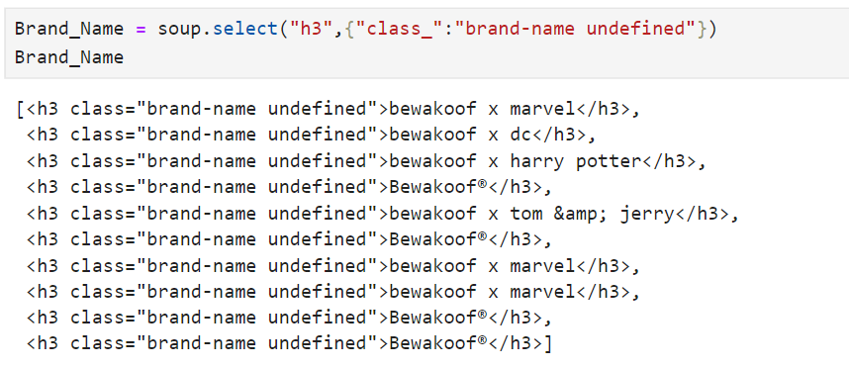

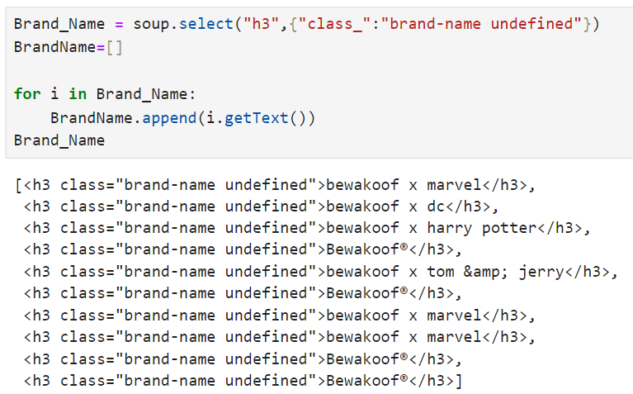

1. **Accessing the Brand_** **description:**

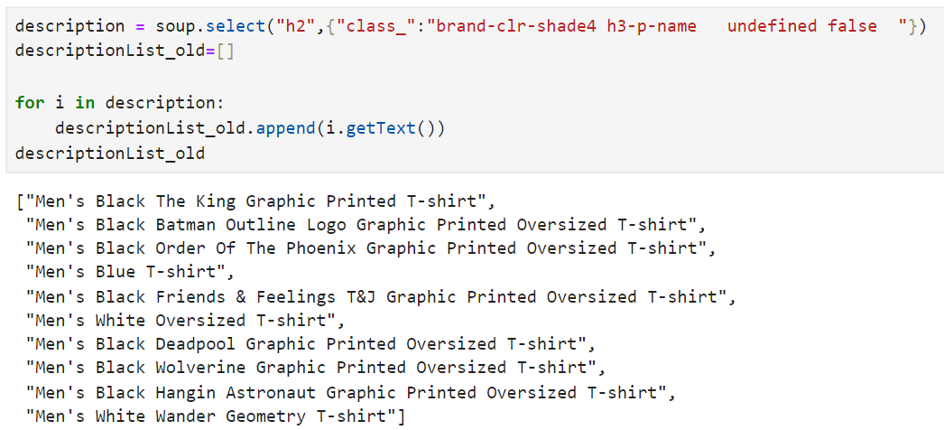

1. **Accessing the Brand_Price:**

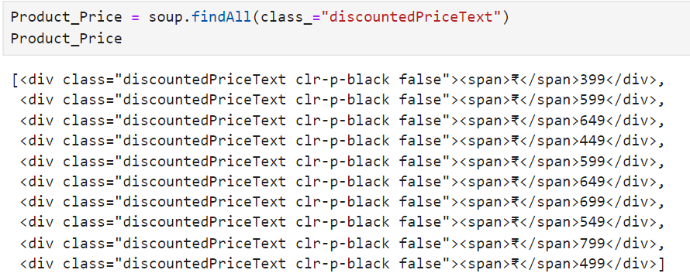

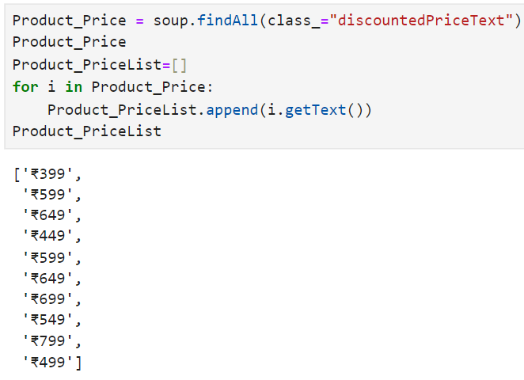

1. **Using RegEx to remove the '₹' symbol from the product price list:**

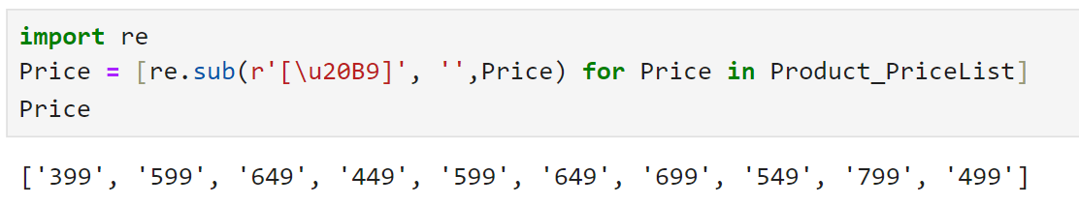

1. **Accessing the TribeMember_Price:**

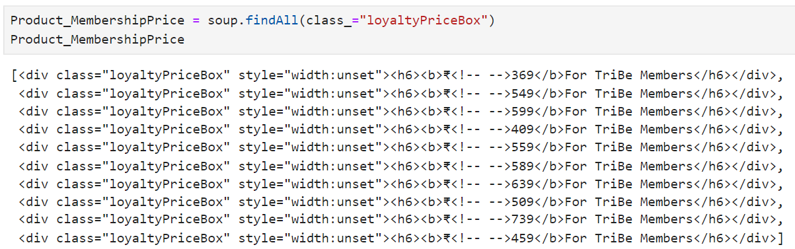

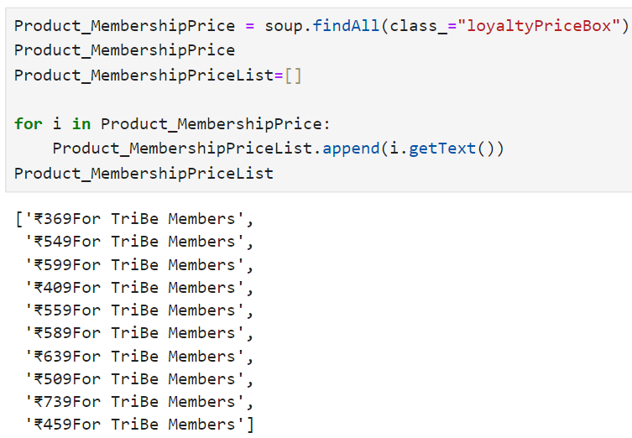

1. **Using RegEx to remove the '₹' symbol & “For Tribe Member” from the TribeMember_Price:**

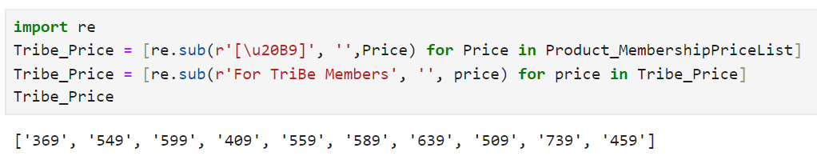

1. **Accessing the Product_Type:**

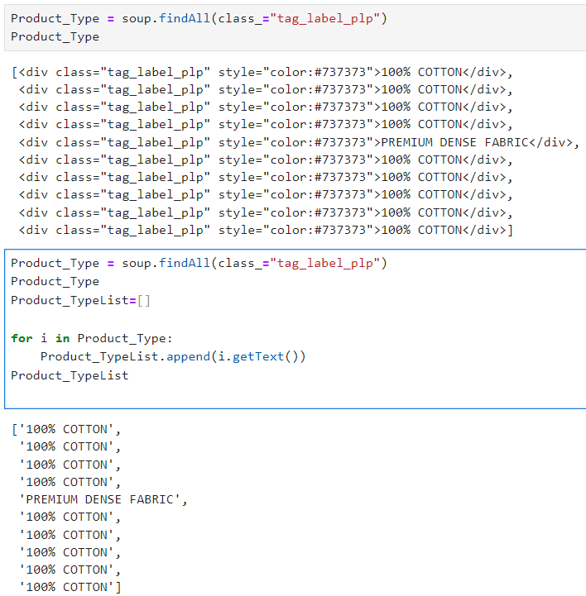

1. **Creating DataFrame:**

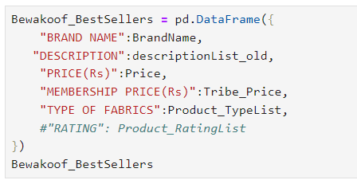

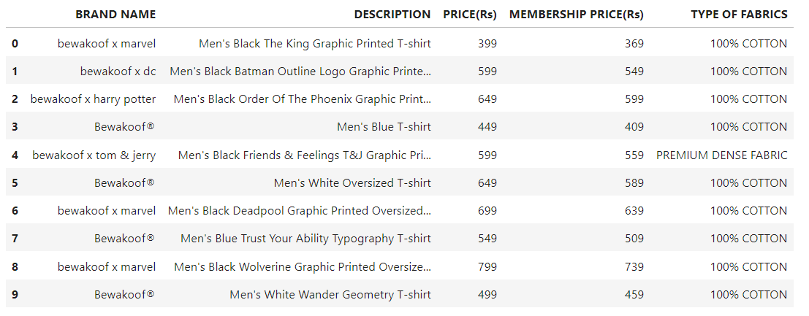

**10. Converting and Storing DataFrame in the form of a CSV file and opening the file in application:**

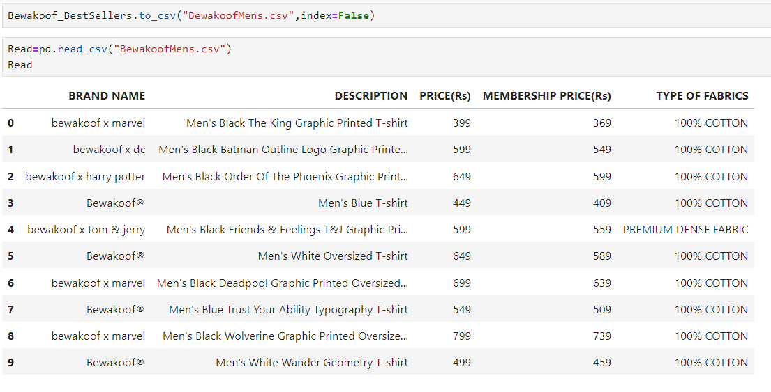

1. **Conclusion:**

The web scraping project aimed at analyzing Bewakoof's men's bestseller products has yielded valuable insights into current fashion trends and consumer preferences. The key findings and reflections from the project are summarized below:

**Key Findings**

Top-Selling Products: The data revealed a clear preference for certain styles and categories among Bewakoof's bestsellers. For instance, [specific product categories, e.g., graphic tees, joggers] consistently appeared at the top of the list.

**Pricing Trends:** The analysis showed a range of price points that are popular among buyers, indicating a balance between affordability and perceived value.

[Include any specific pricing trends or patterns if applicable.]

**Product Attributes:** Features such as [specific attributes like color, design, material] were frequently associated with bestselling items, highlighting trends in consumer preferences.

**Seasonal Variations:** The data suggested that certain products experience fluctuations in sales based on seasonal changes or promotional events.

**Reflections on the Process**

**Data Accuracy:** The scraping process was successful in extracting relevant data, but it is important to note any limitations related to data accuracy or completeness. Issues such as incomplete product descriptions or missing images were occasionally encountered.

**Technical Challenges:** Implementing and maintaining the web scraping script required attention to changes in the website's structure, and there were occasional challenges with data formatting.

**Ethical Considerations:** Throughout the project, ethical guidelines for web scraping were followed, ensuring that the data collection did not disrupt the website’s normal operations.

**Recommendations for Future Work**

**Enhanced Data Analysis:** Future projects could benefit from more advanced data analysis techniques, such as sentiment analysis or trend forecasting, to gain deeper insights into consumer behavior.

**Broader Scope:** Expanding the scope to include additional categories or time periods could provide a more comprehensive understanding of Bewakoof's product performance over time.

**Competitor Analysis:** Comparing Bewakoof's bestselling products with those of competitors could offer a valuable perspective on market positioning and opportunities for differentiation.

**Continuous Monitoring:** Setting up an automated system for regular updates could help track ongoing changes in bestseller trends and adapt strategies accordingly.

**Overall, this web scraping project has provided a solid foundation for understanding the dynamics of Bewakoof’s men’s bestselling products and offers actionable insights for future business and marketing strategies.**

